**M.MOHANA**

**231901031**

**Week 5 sample program**

**1.**

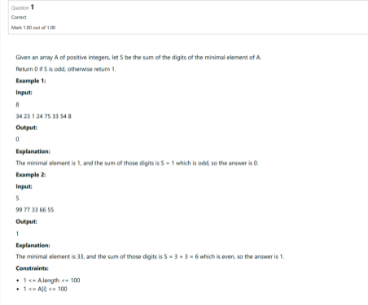

**Program:**

import java.util.Scanner; public

class MinElementDigitSum {

public static void main(String[] args) {

Scanner scanner = new Scanner(System.in);

System.out.print("Enter the number of elements in the array: ");

int size = scanner.nextInt(); if (size <= 0) {

System.out.println("Array size must be greater than zero.");

return;

}

**CSE(CYBER SECURITY)**

int[] array = new int[size];

System.out.println("Enter the elements of the array:"); for (int i = 0; i < size; i++) {

array[i] = scanner.nextInt();

}

int minElement = array[0];

for (int i = 1; i < size; i++) {

if (array[i] < minElement) {

minElement = array[i];

}

}

int sumOfDigits = 0; int

number = minElement; while

(number > 0) { sumOfDigits

+= number % 10;

number /= 10;

}

System.out.println(sumOfDigits % 2 == 0 ? 1 : 0); }

}

**Output:**

**CSE(CYBER SECURITY)**

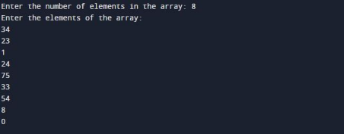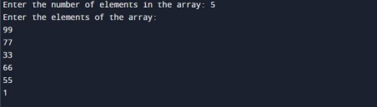

**2.**

**CSE(CYBER SECURITY)**

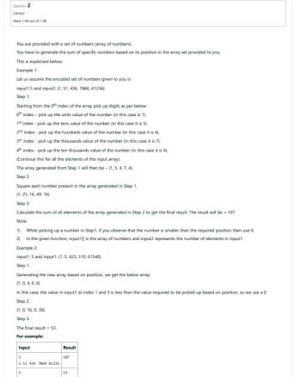

**Program:**

import java.util.Scanner; public class

DigitSumCalculator { public static

void main(String[] args) {

Scanner scanner = new Scanner(System.in);

System.out.println("Enter the number of elements in the array:"); int n = scanner.nextInt(); int[] input = new int[n]; System.out.println("Enter the elements of the array:"); for (int i = 0; i < n; i++) {

input[i] = scanner.nextInt();

}

**CSE(CYBER SECURITY)**

int finalSum = calculateFinalSum(input);

System.out.println("Final result = " + finalSum);

}

public static int calculateFinalSum(int[] input) {

int finalSum = 0; for (int i = 0; i <

input.length; i++) { int currentNumber =

input[i]; int digitPosition = i + 1;

int digit = getDigitAtPosition(currentNumber, digitPosition);

finalSum += digit * digit;

}

return finalSum;

}

public static int getDigitAtPosition(int number, int position) {

String numberStr = Integer.toString(number); int length =

numberStr.length(); if (length < position) {

return 0;

}

char digitChar = numberStr.charAt(length - position);

return Character.getNumericValue(digitChar);

}

}

**Output:**

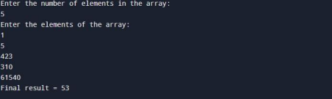 **3.**

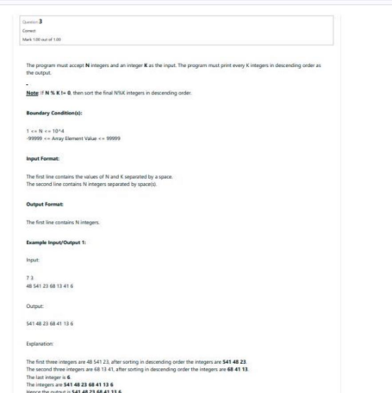

**Program:**

import java.util.Arrays; import java.util.Scanner; public class SegmentSorter { public static void main(String[] args) {

**CSE(CYBER SECURITY)**

Scanner scanner = new Scanner(System.in); System.out.println("Enter the values of N and K:"); int N = scanner.nextInt(); int K =

scanner.nextInt();

System.out.println("Enter the " + N + " elements:"); int[] arr = new int[N]; for (int i = 0; i < N; i++) { arr[i] = scanner.nextInt();

}

for (int i = 0; i < N; i += K) {

int end = Math.min(i + K, N);

Arrays.sort(arr, i, end);

reverse(arr, i, end - 1);

}

for (int num : arr) {

System.out.print(num + " ");

}

}

public static void reverse(int[] arr, int start, int end) { while (start < end) { int temp = arr[start]; arr[start] = arr[end]; arr[end] = temp; start++;

end--;

}

}

}

**Output:**

**CSE(CYBER SECURITY)**

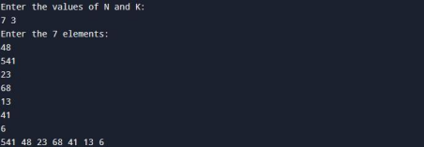

**CSE(CYBER SECURITY)**